AI course 2018

Exercise 1 Search

- Below we have created a simple model of a terrain that an avatar will move around. Currently it is standing in the position marked “Start”. You wish the avatar to reach Goal.

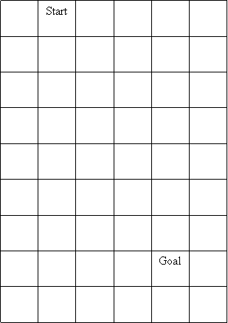

Create a depth first algorithm and demonstrate how the use of this will help the avatar to find a way to reach its Goal state. Let the program that you create trace out the path that the avatar will use.

b. Do the same as above but use a breadth first algorithm. Let the program that you create trace out the path that the avatar will use.

c. Create an A* algorithm that lets the avatar find the shortest path from Start to Goal. What kind of heuristic function will you apply for h(n)? For this task the terrain is assumed 3 dimensional (had a z axis too). The terrain could be characterized as shown below:

Start
Goal

The white color represents a distance or cost of 1. The green color represents a distance or cost of 2.The red color represents a distance or cost of 3. It means that traversing a red colored cell will imply a cost of 3 x 1 the cost of a white cell.

Load up executable and source (zipped) on Friday at 11:00 and prepare to demonstrate your program and show code afterwards

